Implementation
The implementation outlines the approach taken when completing this project. The primary objective was to build a system that was clear, realistic, and a technically justified roadmap that translated the design into a fully function prototype. The aim was to have the system design align with the privacy, reproducibility, and ethical guidelines which are relevant to the financial document analysis.

Implementation Approach and Development Methodology
The implementation followed an iterative Agile approach. Agile was chosen for the project development due to its incremental features. These increments are verified through testing, then refined over a series of sprints. Another reason for choosing this model was it ability to handle the integration of multiple technologies across different runtime environments.
The project development was tracked and managed using GitHub. Features such as branches, pull requests, and semantic commit messages proved to be instrumental for traceability and maintainability throughout the implementation. GitHub also aligns with the best practices set out in software development and also the guidelines set out for the project itself. (Git Best Practices – How to Write Meaningful Commits, Effective Pull Requests, and Code Reviews, 2022).
A weekly sprint cycle was adopted for the implementation aspect of the project. Each cycle had distinct deliverables, for example document extraction, NER module integration, and anomaly rule development. At the conclusion of each of the sprint cycles, the functional progress was accessed and logged into the project documentation. This went to maintain the project timeline and avoid tie constraints in the other sprint cycles.

Development Environment and Tools
As stated in the design section, the system consists of a three-level technology stack. The frontend of the system was developed using React, Node.js/Express for the backend, and a Java/Python NLP pipeline. This separation ensures the system is modular, that testing is feasible, and that the system aligned with the architecture design which was defined earlier.
React.js was used to create the frontend environment for the system. This made use of various functional component within the React library, such as Hooks and sematic HTML.
Figure 9 React Imports
The design elements of the system aimed to cover the accessibility requirements of the project. These were supported through the WCAG-aligned design choices which include ARIA labels and implementing proper colour contrast. (ARIA: aria-label attribute - ARIA | MDN, 2025).
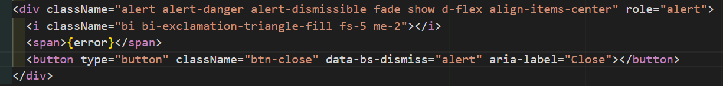
Figure 10 ARIA label
The backend functionality made use of Node.js and Express in order to create lightweight REST endpoints, implement authentication, and coordinate communication with the NLP pipeline.
The security measures put in place consisted of bycrypt hashing and JWT authentication. These features aligned with GDPR and the expectations which surround financial data governance. In addition to this, each of the data files are scheduled to automatically delete themselves from the database after six months. (Jamaludin, no date).
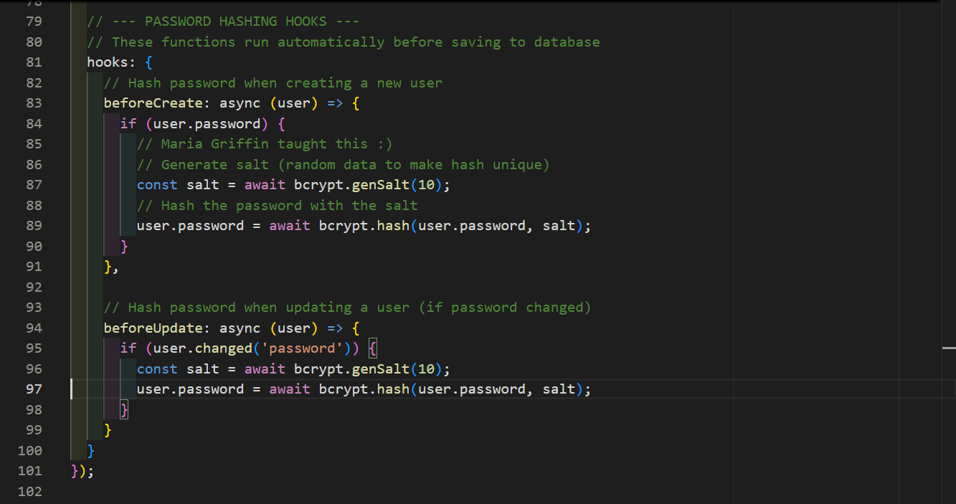
Figure 11 Password Hashing
The NLP pipeline for the for the project was implemented as a modular Node.js and Python workflow rather than a Java-only stack. Apache Tika, with OCR support via Tesseract, was implemented for robust document extraction. Once processed, extracted text is passed through the dedicated NLP microservice for analysis. This backend layer validates the quality of extracted text, enforces minimum text standards, and also keeps the processing steps isolated. Isolation ensures that each stage can be test and improved independently, aligning with best coding practices.
The analysis stage saw the implementation of financial-domain preprocessing with curated stopword handling. This preserves key accounting and reporting terms. Named Entity Recognition is handled with spaCy while topic modelling is performed with TR-IDF features with LDA.
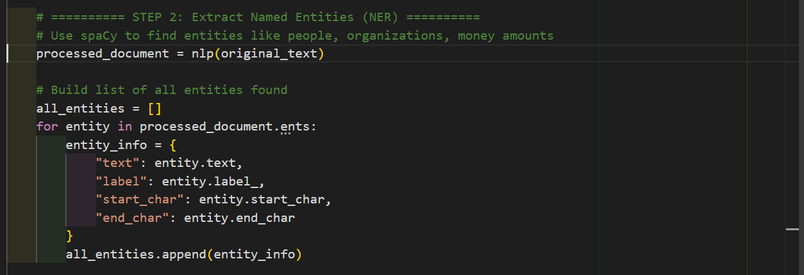
Figure 12 NER Function
The summarisation feature is generated with a sentence-ranking approach with TextRank style for scoring. Financial figure extraction was added using regex with nearby-context checks so that the numeric outputs were more relevant to financial reporting language. This also cut down on the level of noise which slipped through during the extraction process.
def textrank_summary(text, max_sentences=4):
sentences = split_sentences(text)
if len(sentences) == 0:
return text.strip()
if len(sentences) <= max_sentences:
return ' '.join(sentences)

vectorizer = TfidfVectorizer(stop_words='english')
tfidf = vectorizer.fit_transform(sentences)

sim_matrix = cosine_similarity(tfidf)
np.fill_diagonal(sim_matrix, 0.0)

# Normalize rows to make a stochastic matrix
row_sums = sim_matrix.sum(axis=1, keepdims=True)
row_sums[row_sums == 0] = 1.0
transition = sim_matrix / row_sums

n = len(sentences)
scores = np.ones(n) / n
damping = 0.85

for _ in range(30):
scores = (1 - damping) / n + damping * transition.T.dot(scores)

weighted_scores = []
for idx, sentence in enumerate(sentences):
weighted_scores.append((idx, scores[idx] * sentence_financial_weight(sentence)))

top_indices = [idx for idx, _ in sorted(weighted_scores, key=lambda item: item[1], reverse=True)[:max_sentences]]
top_indices.sort()

return ' '.join(sentences[idx] for idx in top_indices)

transition = sim_matrix / row_sums

n = len(sentences)
scores = np.ones(n) / n
damping = 0.85

for _ in range(30):
scores = (1 - damping) / n + damping * transition.T.dot(scores)

weighted_scores = []
for idx, sentence in enumerate(sentences):
weighted_scores.append((idx, scores[idx] * sentence_financial_weight(sentence)))

top_indices = [idx for idx, _ in sorted(weighted_scores, key=lambda item: item[1], reverse=True)[:max_sentences]]
top_indices.sort()

return ' '.join(sentences[idx] for idx in top_indices)

Code Listing 4 TextRank Summary Function

The design of this system followed the modularity and explainability which as covered in the literature reviewed. (Xing and Paul, 2018).
The Azure combability aspect of the project ended up not being implemented due to time constraints. The system itself covers much of what the Azure aspect would have covered so in the end it did not end up being necessary. Possibly in a future iteration the system will be configured to run in an Azure ML.

Planned Codebase Structure
As the project will be stored and saved on GitHub, the repository was broken up into subfolders. Each folder was assigned to each of the major components of the systems. A separate repository was created to store the documentation and research notes. A GitHub project board replaced the MS Project timeline as it was more compatible as the rest of the project was stored on GitHub.
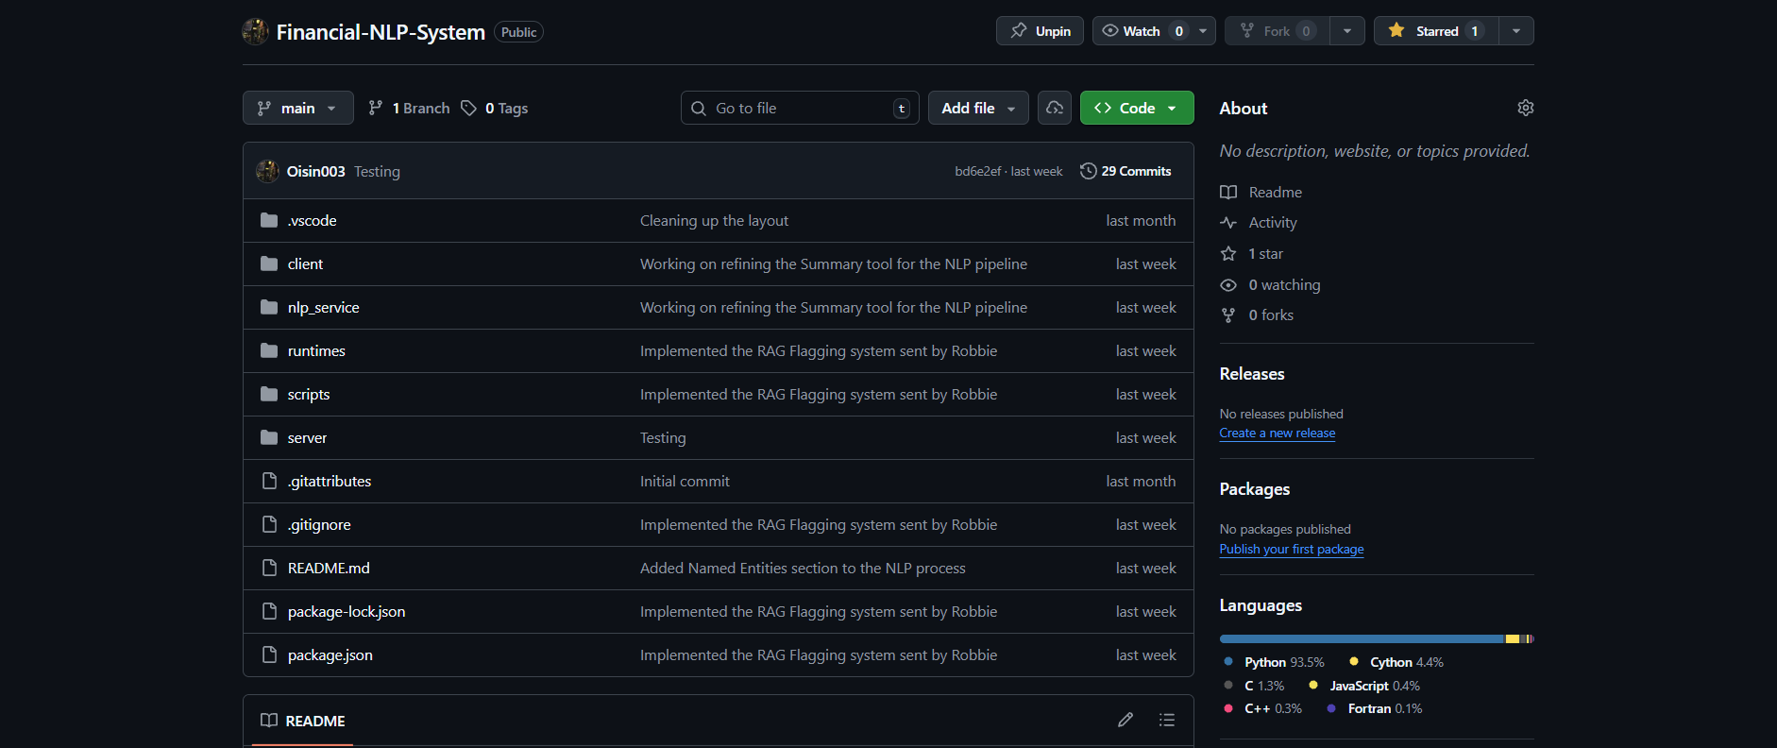
Figure 13 File Structure

Step-by-step Implementation Plan
The system implementation was divided into manageable, sequential sprints which aligned with the technical dependencies.

Sprint 1 – Project Setup, Architecture Scaffolding, and Authentication
Sprint Objective:
Establish the foundational technical environment, repository structure, and core security mechanisms required for subsequent development.
Phase 1: Environment and Repository Setup
- Initialise the GitHub repository with appropriate branching strategy (e.g. main, dev, feature branches).
- Define the high-level folder structure for frontend, backend, and NLP pipeline components.
- Configure development environments for React, Node.js/Express, and Java NLP modules.
- Establish consistent coding standards and commit message conventions to support maintainability.
Phase 2: Backend and Frontend Scaffolding
- Create the basic React application shell, including routing and placeholder views.
- Scaffold the Node.js/Express backend with core middleware (CORS, body parsing, request logging).
- Verify frontend–backend communication through a simple health-check API endpoint.
Phase 3: Authentication and Security Foundations
- Implement secure user authentication using bcrypt for password hashing.
- Integrate JWT-based stateless session management.
- Create protected API routes to ensure that only authenticated users can upload and analyse documents.
- Validate authentication flows using basic test users.
Sprint Deliverables:
- Working frontend and backend skeletons.
- Secure authentication and authorisation mechanism.
- Verified communication between system layers.

Sprint 2 – Document Upload, File Handling, and Extraction Pipeline
Sprint Objective:
Enable secure document ingestion and ensure reliable text extraction from supported file formats.
Phase 1: Secure File Upload and Validation
- Implement document upload endpoints supporting PDF, DOCX, and XLSX formats.
- Enforce file size limits, MIME-type validation, and sanitisation checks.
- Ensure temporary file storage and controlled lifecycle management to reduce data exposure risks.
Phase 2: Text Extraction Integration
- Integrate Apache Tika (and OCR fallback where required) for text extraction.
- Handle multi-page, multi-column, and mixed-content documents.
- Validate extracted text for completeness and readability.
Phase 3: Backend–NLP Pipeline Integration
- Define JSON-based data exchange format between backend and NLP pipeline.
- Ensure extracted text is correctly forwarded for downstream processing.
- Log extraction errors and implement fallback handling for corrupted or unreadable files.
Sprint Deliverables:
- Secure document upload workflow.
- Reliable text extraction pipeline.
- Structured data passed successfully into the NLP layer.

Sprint 3 – Core NLP Pre-processing, Topic Modelling, and NER
Sprint Objective:
Implement the analytical core of the system, focusing on transforming unstructured text into structured, machine-interpretable data.
Phase 1: Text Pre-processing Pipeline
- Implement tokenisation, sentence segmentation, stopword removal, and lemmatisation.
- Introduce finance-aware token retention to preserve domain-specific terminology.
- Benchmark processing times to ensure compliance with performance requirements.
Phase 2: Topic Modelling
- Implement TF-IDF vectorisation and Latent Dirichlet Allocation (LDA).
- Identify dominant financial themes within documents.
- Evaluate topic coherence and adjust parameters as necessary.
Phase 3: Named Entity Recognition (NER)
- Integrate financial-domain NER models to extract entities such as monetary values, dates, organisations, and reporting periods.
- Convert NER outputs into structured JSON objects.
- Validate entity accuracy against sample documents.
Sprint Deliverables:
- Fully operational NLP pre-processing pipeline.
- Topic modelling results with interpretable outputs.
- Structured financial entity extraction supporting downstream analysis.

Sprint 4 – Summarisation, Anomaly Detection, and Explainability
Sprint Objective:
Enhance analytical depth by generating explainable summaries and detecting potential financial anomalies.
Phase 1: Extractive Summarisation
- Implement TextRank-based extractive summarisation.
- Ensure numerical stability and factual accuracy in generated summaries.
- Prepare summaries for later evaluation using ROUGE and BLEU metrics.
Phase 2: Rule-based Anomaly Detection
- Define interpretable anomaly rules aligned with financial domain expectations.
- Implement traffic-light classification (Green, Amber, Red).
- Associate each anomaly flag with a clear rationale to support explainability.
Phase 3: System Integration and Transparency
- Ensure summarisation and anomaly outputs integrate cleanly with previous NLP stages.
- Verify that all analytical decisions can be traced back to extracted entities or rules.
- Refine outputs to align with explainable AI principles.
Sprint Deliverables:
- Reliable extractive summaries.
- Transparent, rule-based anomaly detection module.
- End-to-end analytical workflow within the NLP pipeline.

Sprint 5 – Testing, Refinement, and Project Consolidation
Sprint Objective:
Stabilise the system, validate requirements, and finalise documentation for submission and evaluation.
Phase 1: Testing and Validation
- Conduct unit testing across frontend, backend, and NLP components.
- Perform integration testing to validate full document processing workflows.
- Execute performance and security testing against defined non-functional requirements.
Phase 2: Usability Review and Refinement
- Review system outputs with respect to clarity, relevance, and usability.
- Refine UI presentation of summaries, entities, and anomaly indicators.
- Address usability feedback and correct identified issues.
Phase 3: Documentation and Final Review
- Finalise technical documentation, system diagrams, and code comments.
- Ensure traceability between requirements, implementation, and testing outcomes.
- Prepare the system for final demonstration and academic assessment.
Sprint Deliverables:
- Fully tested and stable prototype.
- Complete documentation and evaluation readiness.
- System aligned with all functional and non-functional requirements.
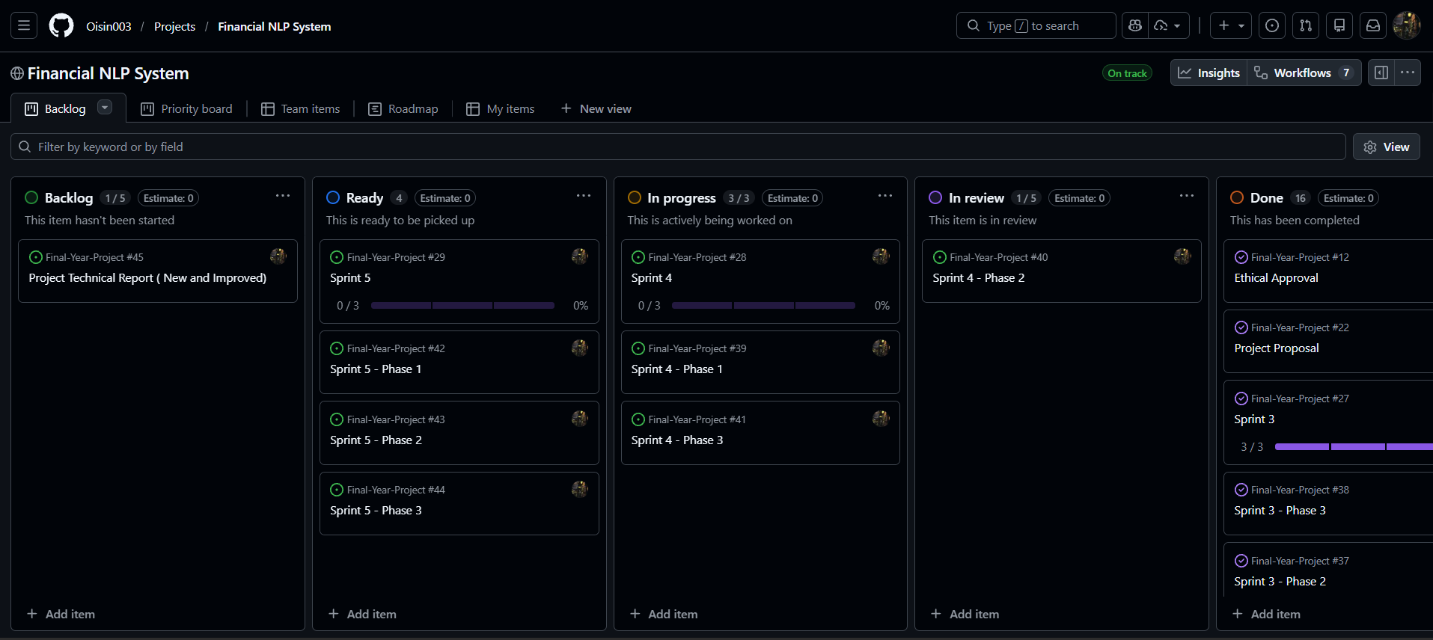
Figure 14 Project Board

Deployment and Runtime Strategy
Originally the deployment was going to be split into two modes, Local and Cloud. The Cloud aspect of the system was sideline in favour of focusing on Local deployment.

Local deployment
In local deployment, the system runs entirely on the user’s machine. This deployment method is best suited for offline testing, iterative deployment, and ensures privacy during the workflow. In addition to this, the package folder will automatically install all dependencies when the system first runs. This ensures that the system can run on any machine without the user needing to set up an environment.
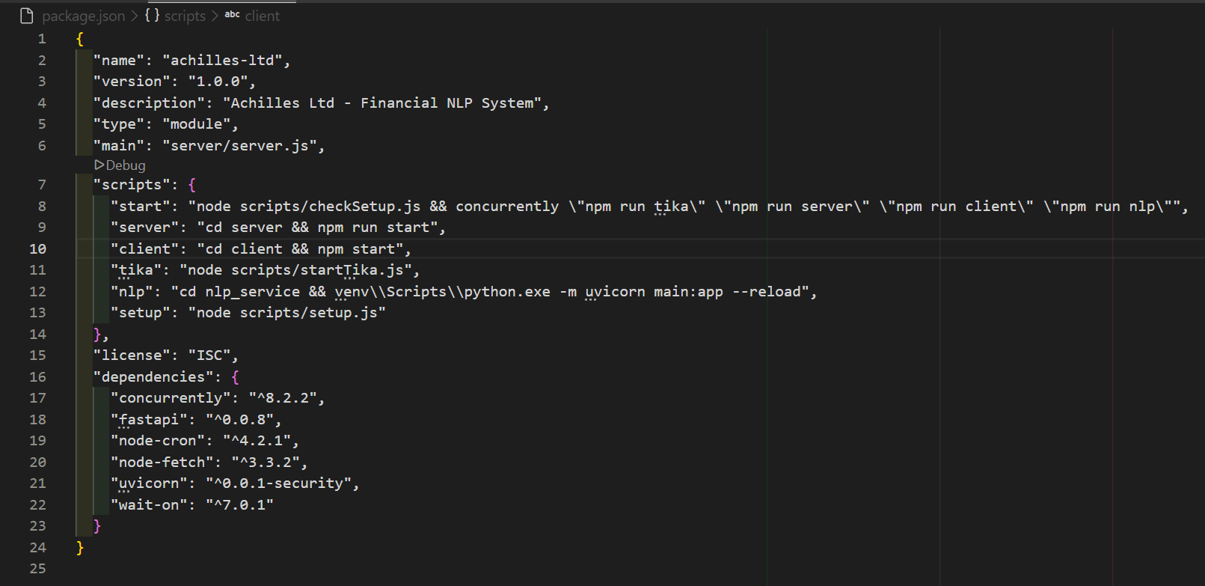
Figure 15 Package File
As stated, the backend section hosts the NLP pipeline. This allows for implementation and extraction without the need for external services. This deployment method also ensures that the financial data, which is sensitive in nature, does not leave the constraints of the system and remains isolated.

Cloud Deployment
If time had allowed, the system would have been able to support deployment to the cloud via Azure App Services. This mode of deployment would have the NLP pipeline be containerised and executed within an Azure instance. This would have allowed for elasticity in terms of scaling the project and implementing other Azure services.

Privacy, Security, and Data Governance
As stated, each of the uploaded documents will remain private and confidential. The processing of said documents adheres to GDPR guidelines of data minimisation, purpose limitation, and storage limitation. (Regulation (EU) 2016/679 of the European Parliament and of the Council of 27 April 2016 on the protection of natural persons with regard to the processing of personal data and on the free movement of such data, and repealing Directive 95/46/EC (General Data Protection Regulation) (Text with EEA relevance), 2016). The uploaded documents will be automatically removed from the database after a period of six months.
When handling errors that arise during configuration and setup, the logs excluded the documents content. The aim was to have the logs reference the documents IDs rather than the raw text itself.
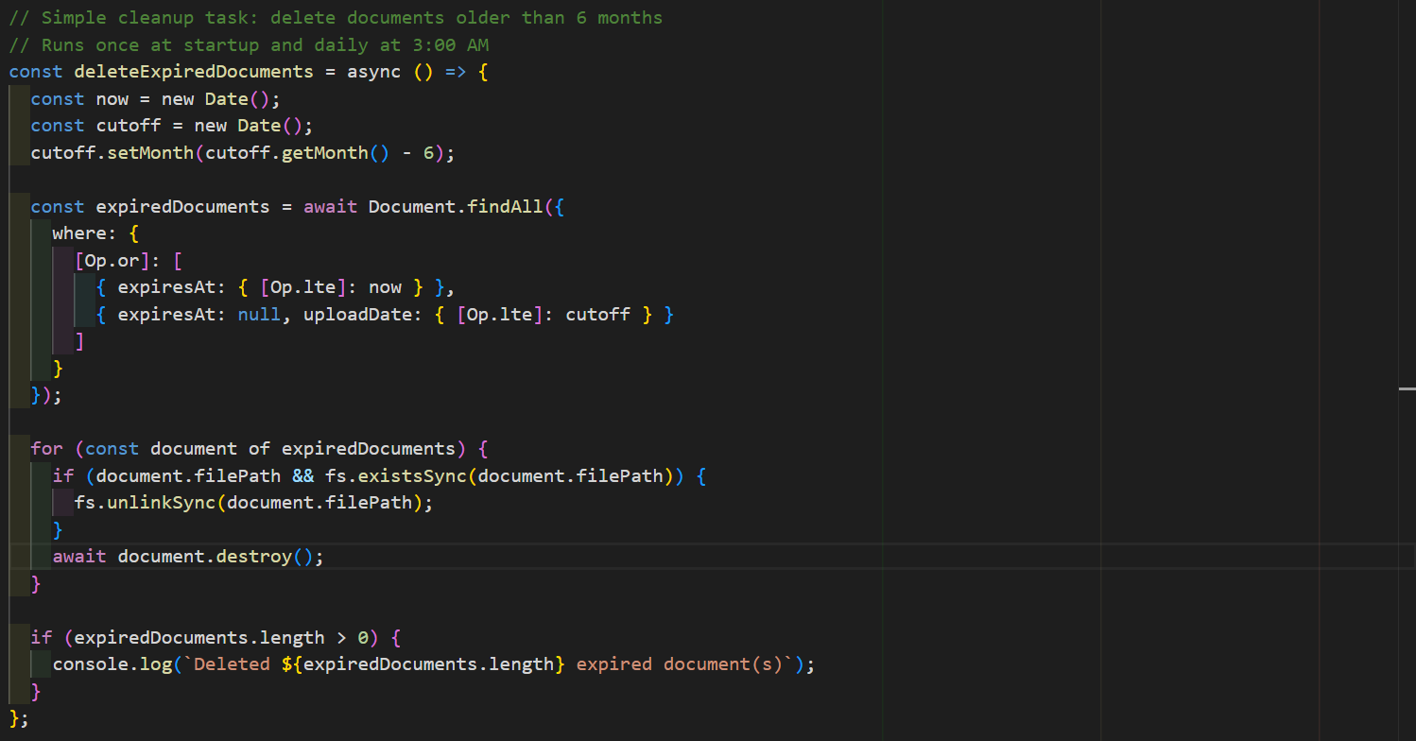
Figure 16 Document Deletion

Error Handling and System Observability
As security is a key concept in this project, the system was developed using defensive techniques. These techniques were implemented to detect invalid user input, invalid file types, or extraction failures.
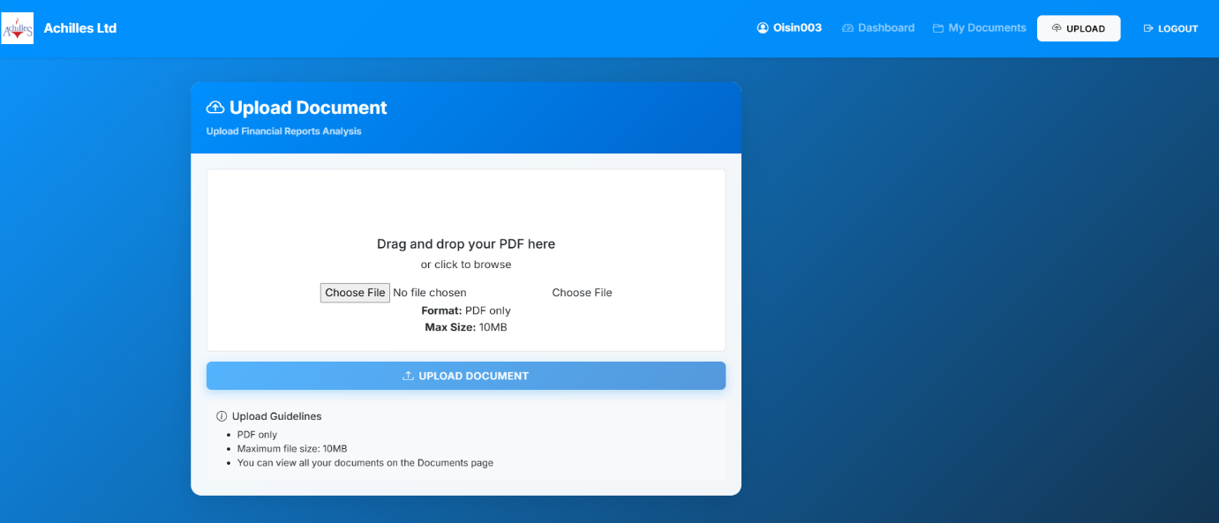
Figure 17 Document Upload
The backend controllers return structured JSON error messages to the user should an error be detected. The NLP aspect of the system supports timeouts and fallback states.
A structured logging framework was developed to generate diagnostic logs. This will support debugging, auditability, and maintainability within the system. It also aligns with best practices for a complex NLP pipeline. (Isaiah, 2026).
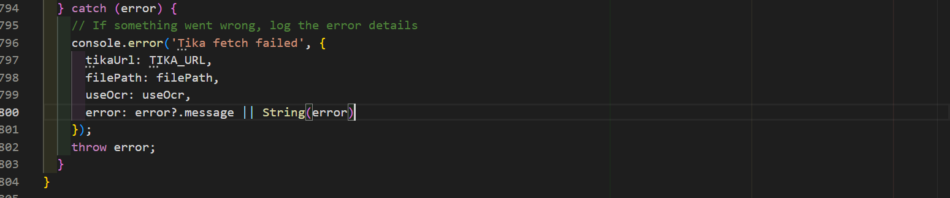
Figure 18 Text Extraction Error Catching

Testing Strategy
A full testing strategy will be covered in Section 6 of this report. Below are a few of the key tests which will be included:
- Unit tests
- Validation of accuracy of extracted information
- Performance testing
- UI validation
These tests will target both the functional and non-functional requirements of the system.

